Project Procurement Status
How to use the report
For TKMS buyers and the weekly managers’ meeting · Fishbowl BI report “- Purchasing - TKMS Project Procurement Status” · October 2026

1. What the report shows
For each project, the report counts the parts the job needs and shows where each one is up to: To Be Ordered, Ordered, In Stock or Received. It replaces the weekly Project Procurement Ordering Status spreadsheet.
Each week, the aim is for To Be Ordered to fall to 0 while Ordered and Received rise. Every number in the report can be traced: click it to see the parts, MO lines and PO lines behind it.
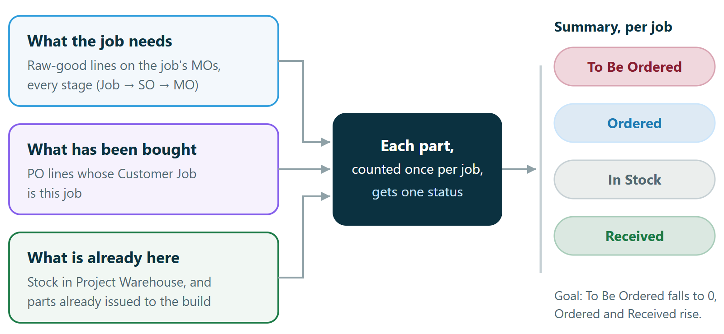
Figure 1. Where the numbers come from.

Three things to know
- A job is a customer. Each project phase is a customer in Fishbowl, such as P2410110. Its sales order and manufacture orders are linked to that customer.
- Each part counts once per job, however many BOM lines or stages it appears on. Sub-assemblies built on the job’s own MO aren’t counted, and neither are labour and overhead.
- A PO counts for a job only through the Customer Job on the PO line. The PO header doesn’t matter, and one PO can carry lines for several jobs.

2. Opening the report and choosing jobs
- In Fishbowl, open BI Reports and run - Purchasing - TKMS Project Procurement Status.
- Click Jobs and tick the jobs you want. Leave it empty to see every open job.
- Click Finished jobs to also list jobs whose MOs are all fulfilled or closed.
- To reuse a set of jobs, save it as a view with the bookmark button, for example Managers’ meeting. Next time, pick it from the same button.
The report remembers the jobs and tab you last used.
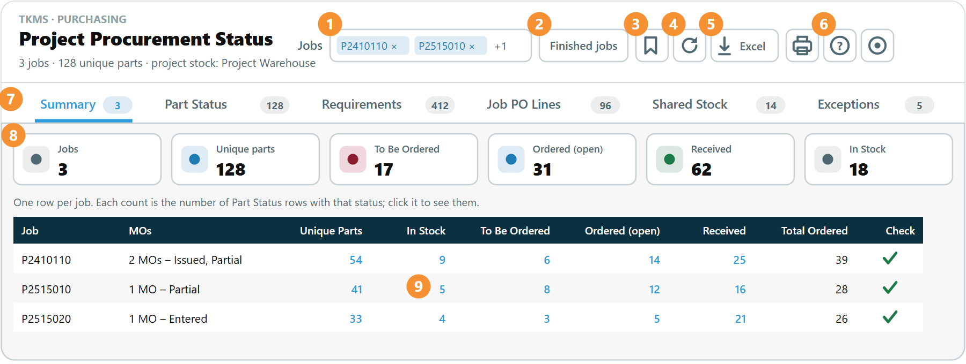
Figure 2. The report screen. The numbers match the table below.
# | Control | What it does
1 | Jobs | Choose the jobs to show. Empty means every open job.
2 | Finished jobs | Also list jobs whose MOs are all fulfilled or closed.
3 | Saved views | Save the jobs you’ve picked as a view, or open one. An administrator can publish a view for everyone.
4 | Refresh | Reload from Fishbowl after you change a PO or an MO.
5 | Excel and Print | Excel downloads every tab, as filtered, into one workbook. Print prints the tab you’re on.
6 | Help and Settings | Help explains the rules on screen. Settings is covered in section 8.
7 | Tabs | Six views of the same data, each with its row count.
8 | Total tiles | Totals for the selected jobs. Click a tile to see its rows.
9 | Counts | Every blue number is a link to the rows behind it.

3. How a part’s status is decided
Each part a job needs gets exactly one status. The report asks these questions in order and stops at the first yes.
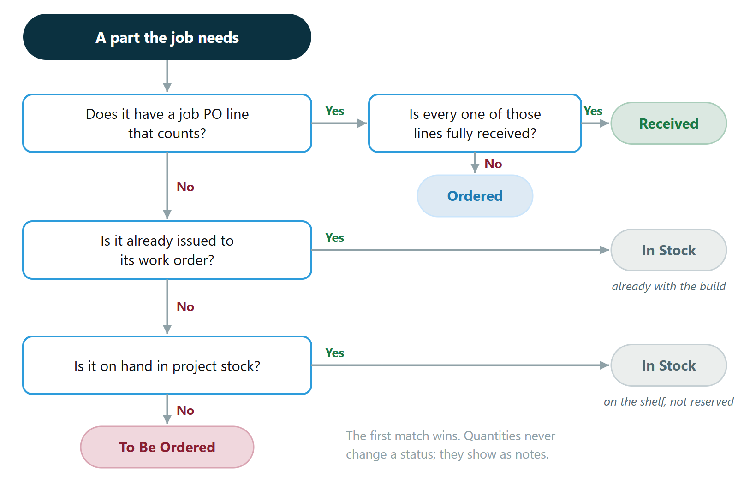
Figure 3. How a part’s status is decided.
Status | What it means | What to do
Received | Bought for this job, and every line has arrived. | Nothing.
Ordered | Bought for this job, and at least one line is still to arrive. | Chase it if it’s late. Job PO Lines shows the scheduled date.
In Stock | Not bought for this job, but already issued to its work order, or on the shelf in Project Warehouse. | If the Stock Note says the part is shared, check there’s enough for every job.
To Be Ordered | Not bought for this job, and none on the shelf. | Raise the PO, with the Customer Job set on the line.

Which PO lines count
- The line’s Customer Job is the job.
- The PO is Issued, Partial, Fulfilled or Closed Short. Bid Requests and POs waiting for approval don’t count until they’re issued.
- It’s a purchase line. Void, credit return, shipping and outsourced lines don’t count.
- A line closed short counts as neither received nor ordered, because nothing more is coming on it. Raise a new PO for the rest.
Quantities never change a status. If the job’s PO is for less than it needs, Part Status says so in the Qty Note, for example Ordered 10 < required 12 ea. Stock in Project Warehouse isn’t reserved for one job either. When other open jobs need the same part, the Stock Note says whether there’s enough for all of them.

4. The six tabs
Tab | One row per | Use it to
Summary | job | See the counts for the meeting. Click a count to see those parts.
Part Status | job and part | See each part’s status and the reason for it.
Requirements | MO raw-good line | See why a part is on the job, and which lines aren’t counted.
Job PO Lines | PO line with a Customer Job | See which PO lines count, and why one doesn’t.
Shared Stock | part and job | See parts several open jobs need, against stock on hand.
Exceptions | problem found | Find data mistakes that would make the summary wrong.

Working with a table
- Type in the filter box under a column heading to narrow the rows. On columns such as Job and Status, pick from the list.
- Click a heading to sort. Drag a heading to move the column, or drag its edge to resize it. The report remembers your layout.
- Order, part and PO numbers are links. Click one to open the record in Fishbowl.
- The Check column on Summary shows a tick when the counts add up. A red cross means a fault in the report: take a screenshot and send it to Fishbowl support.

5. Tracing a number
Every count leads to the rows behind it. For example, to see why job P2410110 has 6 parts To Be Ordered:
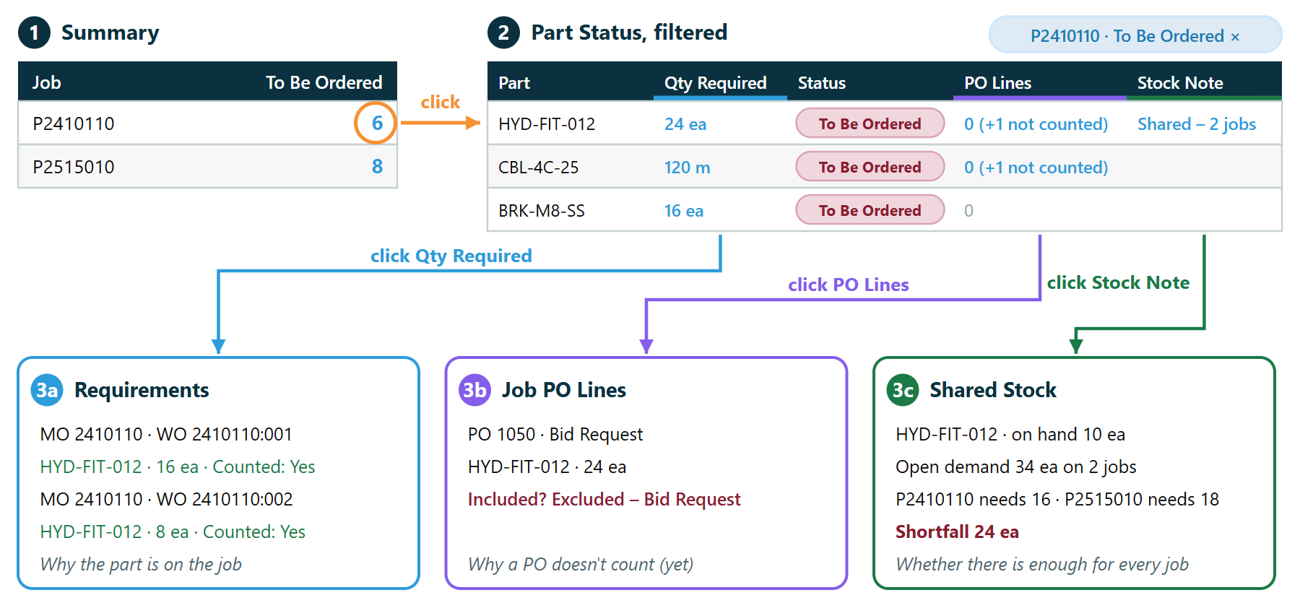
Figure 4. Tracing a To Be Ordered count. The PO for HYD-FIT-012 is still a Bid Request, so it doesn’t count yet.
- On Summary, click the 6 under To Be Ordered. Part Status opens, showing only those parts.
- Read the Status Reason. It says what decided the status, such as No PO for this job; nothing on hand in project stock, or PO 1043 closed short, 80 of 120 received.
- To look further, click Qty Required for the MO lines, PO Lines for the job’s PO lines (including any that don’t count), or the Stock Note for the shared-stock detail.
The blue chip above a table shows what it’s filtered to. Click its × to see every row again.

6. A weekly routine

Figure 5. Before the managers’ meeting.
- Open the report and pick your saved view from the bookmark button.
- Open Exceptions. It lists the data mistakes that would make the summary wrong. The most common is a PO line without its Customer Job.
- Fix them in Fishbowl, then click Refresh.
- On Summary, review To Be Ordered for each job. Click a count to see which parts and why.
- Click Excel to download every tab as one workbook for the meeting. If nothing seems to happen, the save window may be behind Fishbowl: press Alt+Tab.

7. When a number looks wrong
You see | Usually because | What to do
A part shows To Be Ordered, but you’ve bought it | The PO line has no Customer Job, or it’s set to another job | Set the Customer Job on the PO line, then Refresh. Exceptions lists these lines.
PO Lines shows “+1 not counted” | The PO is a Bid Request or waiting for approval, or the line is void | Issue the PO. Job PO Lines gives the reason for each line.
A part went from Ordered back to To Be Ordered | Its PO line was closed short | Raise a new PO for the rest.
A job is missing from the Jobs list | Its MO isn’t linked to the sales order, or it has no MO yet | Exceptions lists these as “MO not linked to an SO” or “SO with no MO”.
Qty Required says “no conversion” | The MO line’s unit has no conversion to the part’s stocking unit | Add the conversion in the UOM module.
A part we make shows To Be Ordered | It’s built on its own MO, not as a stage of the job’s BOM | No PO is needed. The Status Reason says “Made in-house”.
A job PO line says “Not on job’s BOM” | The Customer Job is wrong, or the BOM changed after ordering | Correct the Customer Job, or check the BOM.
A yellow banner says no project location group is set | Project stock hasn’t been chosen yet | Ask your administrator to set it in Settings.

8. Settings, and terms used

Settings
An administrator sets two things for everyone in Settings (the gear button), then clicks Save for everyone:
- Project stock: the location groups whose stock counts as on hand, normally Project Warehouse. Sonic Stock Program stock doesn’t count until it’s transferred in.
- Parts not counted: part types left off the job’s list. Labour and overhead are left out by default.
Anyone else can try other choices; they last until the report is reopened. Show debug console is for troubleshooting with Fishbowl support.

Terms used
Term | Meaning
Job | A customer in Fishbowl named after the project and phase, such as P2410110.
Customer Job | The field on each PO line that says which job the line was bought for.
Project stock | Stock in the Project Warehouse location group.
Issued to the build | Taken from stock for the job’s work order.
Stage | A sub-assembly built on the job’s own MO as a step of a bigger build. It isn’t bought, so it isn’t counted.
Closed short | A PO line closed before everything arrived. Nothing more is coming on it.

